**Project Documentation & Submission**

Public transportation and optimization

|  |  |
| --- | --- |
| DATE | 1/11/2023 |
| PROJECT NAME | PUBLIC TRANSPORTATION AND OPTIMIZATION |

[**Objectives of public transportation include**](https://trid.trb.org/view/194480):

* Ensuring mobility of the entire population, including the poor and handicapped.
* Permitting commuters to reach city centers and assuring their viability.
* Contributing to quality of life.
* Conserving scarce resources such as land and energy.
* Becoming more accessible, more reliable, and more efficient.

**IoT based real-time traffic monitoring system:**

**Introduction:**

The sustainability and smartness of the smart city concept rely on the [technologies](https://www.sciencedirect.com/topics/earth-and-planetary-sciences/science-and-technology) adopted to improve the people’s [quality of life](https://www.sciencedirect.com/topics/medicine-and-dentistry/quality-of-life). The smart city governance is one significant aspect of smart city initiatives, which will facilitate the planning techniques for better decision making [[11](https://www.sciencedirect.com/science/article/pii/S2589791820300207#bib11),[14](https://www.sciencedirect.com/science/article/pii/S2589791820300207" \l "bib14)]. One of the key elements of the smart city governance framework is the public value generated out of the smart services provided .

The government has to work on different aspects of smart city solutions such as smart [health care](https://www.sciencedirect.com/topics/medicine-and-dentistry/health-care), [smart building](https://www.sciencedirect.com/topics/engineering/intelligent-buildings) management, smart traffic management, smart parking solutions, smart transportation, etc. to generate public value for the service they provided. The emergence of the [internet of things](https://www.sciencedirect.com/topics/engineering/internet-of-things) (IoT) has evolved the concept of smart cities. In a smart city environment, the physical infrastructures of the city are equipped with smart devices, which continuously produce multidimensional data in different spaces and these data are processed to achieve intelligence for the infrastructure . Ultimately, intelligence is applied to improve the socio-economic activities of the society.

. The transportation governing authorities mostly install the [traffic monitoring](https://www.sciencedirect.com/topics/earth-and-planetary-sciences/traffic-monitoring) devices on urban roads, hence such application providers (e.g. Google application programming interface) deliver updates on urban traffic congestion. Besides, such applications also use crowdsourcing with location-based services to improve traffic density prediction. They do expect smart technologies within the vehicle or any smart mobile device with the driver of the vehicle to receive real-time traffic updates. The concern here is that the users require smart devices to access these applications and mostly the services are limited to urban roads.

The system follows a layered architecture with four layers:

1. a sensing layer with active things and sensors,
2. a network layer represents the mode of communication and protocols,
3. service layer indicates the data analysis and storage, and
4. application layer describe the end-user applications. The sensing layer collects vehicle data through the sensors installed on roadsides and the WiFi-based [microcontroller](https://www.sciencedirect.com/topics/engineering/microcontroller) transfer the real-time data to the service layer.

Several open-source cloud IoT platforms are available to manage connected devices, data storage, and analysis. Thinger. io, which is an open-source IoT platform for integrating [data fusion](https://www.sciencedirect.com/topics/earth-and-planetary-sciences/multisensor-fusion) applications [[13](https://www.sciencedirect.com/science/article/pii/S2589791820300207#bib13)] acts as a service layer in this study. The end-users receive traffic updates through roadside message display units and dashboards. The physical infrastructures such as sensors and message display units are installed on roadsides at selected road intersections. The message units installed at important road intersections substitutes the smart devices and update drivers on the current traffic scenario. The authorities can also send messages on unusual road incidents along with expected clearance time or alternate route suggestions (if any) to assist emergency vehicle handling. The proposed system aims to generate public value by saving the on-road time of drivers through early warning messages.

In summary, the proposed system has the following features:

(i)Appropriate to estimate traffic congestions on collector roads using road occupancy measure

(ii)Update residents on real-time traffic messages through roadside display units

(iii)Monitor the road density of smart campuses especially during peak hours and help to improve mobility

(iv)Assist authorities to broadcast important traffic incident messages

(v)Provide a real-time dashboard to monitor the traffic updates

**Related work:**

This section first discusses the recent research developments in intelligent traffic management including system models for traffic updates, traffic congestion measures, emergency vehicle handling, and applications of [roadside](https://www.sciencedirect.com/topics/engineering/roadsides) units to deliver messages. Current advances in cost-effective and power-efficient [wireless sensor nodes](https://www.sciencedirect.com/topics/engineering/wireless-sensor-node) for [traffic monitoring](https://www.sciencedirect.com/topics/earth-and-planetary-sciences/traffic-monitoring) follow this. This section also includes specific [printed circuit boards](https://www.sciencedirect.com/topics/engineering/printed-circuit-board) based on [sensor nodes](https://www.sciencedirect.com/topics/engineering/sensor-node) to detect vehicles, estimate speed, and classify them. The discussion includes the features of these nodes, their pros, and cons.

**Real-time traffic updates:**

Real-time traffic monitoring systems play a key role in the transition toward smart cities. A considerable amount of literature has been published on intelligent traffic management systems based on the [IoT](https://www.sciencedirect.com/topics/engineering/internet-of-things" \o "Learn more about IoT from ScienceDirect's AI-generated Topic Pages) paradigm Autonomous traffic sensing is at the heart of smart city infrastructures, wherein smart wireless sensors are used to measure traffic flow, predict congestion, and adaptively control traffic routes. Doing so effectively provides an awareness that enables more efficient use of resources and infrastructure.

Identifying and measuring congestion is the very first step in the traffic management process . The flow, occupancy, density is the widely used traffic congestion measures, which are mostly obtained from images or videos captured by vision systems initially

. Based on these measures, the traffic warning messages are broadcasted through smartphones, radio, televisions, light signals, dynamic variable message signs, or display units. Among them, the mobile-based web applications received much attention among researchers.

Most of the recent developments in delivering real-time traffic updates used the congestion estimates to dynamically control the traffic signal . An IoT based real-time traffic monitoring system is proposed for dynamic handling of traffic signals based on traffic density. The proposed system uses a set of [ultrasonic sensors](https://www.sciencedirect.com/topics/engineering/ultrasonic-sensor) and has two modules: one for vehicle monitoring and other for priority management. The ultrasonic sensors are used to detect vehicles, and the density levels of a given road are sent to an LCD, and the data sent to the server for later usage. In similar research , the authors proposed an ultrasonic sensor-based system model specifically for road intersections. In addition to traffic signal lightings, the system alarms on any false vehicle activities such as crossing the red signals. In another research, an IoT based smart traffic management system is proposed to manage real-time traffic through both central and local servers. The data collection layer uses sensors, cameras, and RFIDs. The application layer automatically controls the traffic signal based on traffic density and provides a daily report through a web application. Besides sensors, video monitoring is also used to estimate traffic congestion density and update traffic signals in real-time.

The internet of connected vehicles is another research development in this area to collect real-time traffic data. The connected vehicles support individual vehicle monitoring which enables efficient emergency vehicle management. Integrating roadside units

(eg: traffic lights) with the vehicular network to ensure the trustworthiness of traffic events . The emergency vehicle (e.g. Police cars, Fire engines, Ambulances) handling is very critical, the delay of every second matter because of the urgency of the services they are providing.

The studies discussed above are tested for highways, and real-time updates are delivered through traffic signals or mobile applications. Instead, this research proposes a system model for real-time traffic updates through roadside message units using an IoT platform Nowadays, digital electronic boards are widely used in smart campuses, that can be also reused (if any) to deliver traffic updates during peak hours. Next, discuss the wireless sensors which are mainly used for vehicle detection, classification, speed estimation, etc.

**Wireless sensors for vehicle data collection**

This section presents the review of sensors that are used for vehicle detection and classification. The sensors used in intelligent traffic monitoring systems can be on-road sensors or in-vehicle sensors. The on-road traffic sensors can be again classified into two types: intrusive and non-intrusive. The intrusive sensors are paved on the road and are costly compared to non-intrusive sensors. The intrusive sensors provide accurate information; however, they are questioned for the expenses in terms of installation. maintenance, repair costs . The maintenance of such sensors requires road lane closures and traffic disruptions. The non-intrusive sensors can be fixed on different parts of roads/roadsides. This includes magnetic sensors , ultrasonic sensors , infrared sensors , acoustic sensors , video cameras Each sensor has its advantages and disadvantages . The video monitoring systems are comparatively costly than other sensors when considering the purchase, installation, andmaintenance cost,

However, the sensors are relatively less expensive in purchase costs. A comparison of different intrusive and non-intrusive sensors have been already reported in a few kinds of research The infrared sensors are sensitive to bad weather; acoustic sensors do not give accurate results during cold temperatures. The magnetic sensors are unable to detect the vehicles which are not moving however, there is no climatic influence. The magnetic sensors are widely used for vehicle detection and classification because of its easy installation, portability, and low cost . The vehicle speed and length can be estimated by one or more magnetic sensors, which will help to approximate the road space occupancy measure.

Besides different types of sensors, a few research efforts have attempted to develop printed circuit boards (PCBs), which can be directly adapted for vehicle detection/speed estimation/classification such as PRS , LCTS ,iVCCS and CPIUS .

[Fig. 1](https://www.sciencedirect.com/science/article/pii/S2589791820300207#fig1) shows the PCBs of PRS, LCTS, and iVCCS sensor nodes. The main objective of all these researches is to design and develop inexpensive and portable sensor nodes. On average, a single sensor node costs an average of $30 and operational for many years .

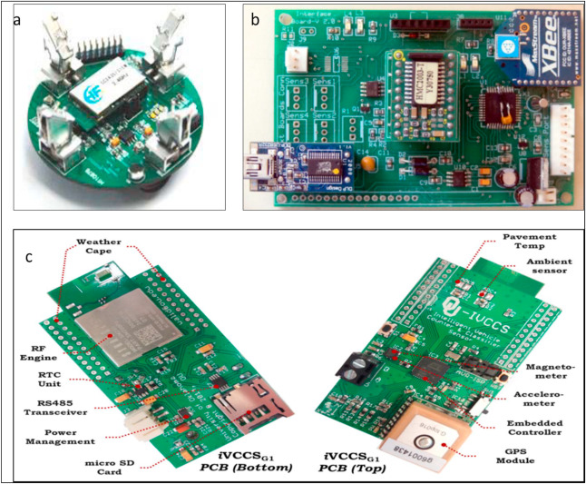

Fig. 1. (a) LCTS Sensor Node, (b) PRS Physical Board ,and (c) iVCCS Physical Board .

CPIUS is the combined passive infrared and ultrasonic sensors (CPIUS) for vehicle classification and speed estimation . The measurements from passive infrared sensors and ultrasonic sensors are used for vehicle classification. They produce a high accuracy in vehicle detection (99%), the [mean absolute error](https://www.sciencedirect.com/topics/engineering/mean-absolute-error) in speed estimation is approximately 5.87 km/h, and a mean absolute error of 0.73 m in vehicle length estimation. The proposed sensing platform contains one ultrasonic rangefinder and two arrays of six passive infrared sensors (Melexis MLX90614) connected to a [microcontroller](https://www.sciencedirect.com/topics/engineering/microcontroller) unit with different components such as an SD card reader, energy monitoring circuit, and flash memory.

The review reveals that magnetic sensors are appropriate for length-based vehicle classification. This is very relevant in the context of this research as the collector roads are mostly occupied with smaller vehicles and a volume to capacity ratio doesn’t fit well.

**The research methodology:**

A robust research methodology is essential to achieve the research objectives. This research work is carried out in five main phases according to [design science research](https://www.sciencedirect.com/topics/engineering/design-science-research) methodology

The five phases are given in

[Fig. 2](https://www.sciencedirect.com/science/article/pii/S2589791820300207#fig2):

1. research background study
2. objective definition,
3. design and development of artifacts,
4. demonstration to show how the artifacts resolve the problems,
5. final evaluation.

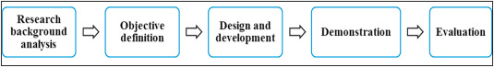

Fig. 2. Research methodology.

A research background study is conducted as part of an objective definition. It has been observed that [wireless sensor networks](https://www.sciencedirect.com/topics/engineering/wireless-sensor-network) are widely applied in traffic management projects and have a significant role in detecting and reducing traffic congestion Many kinds of sensors are used for real-time traffic monitoring. The selection criteria for sensors can be [power consumption](https://www.sciencedirect.com/topics/engineering/electric-power-utilization), cost, sensitivity, reliability, etc. . In addition to the traditional traffic monitoring sensors such as magnetic/infrared/ultrasonic sensors, there are dedicated sensors for vehicle detection and classification as discussed in the related work section.

The road occupancy measure is accurate for both highways and collector roads. Collector roads mostly have small vehicles, which has relatively low length hence a length based road occupancy measure is considered in this research. The road space occupancy measure is a spatial measure calculated by considering the length of the vehicle, the safe distance between vehicles, and a buffer length. The safe distance between the two vehicles is 2 m . When a vehicle enters a road segment, the road occupancy measure is increased by the length of the vehicle and decreased when the vehicle exits from that particular road segment. Based on the literature review, this research has decided to go ahead with magnetic sensors (or magnetic sensor-based PCB) for collecting traffic information as they show good accuracy in vehicle detection. The system design and development, demonstration, and evaluation phases are explained in upcoming sections.

**4. System design and development**

This section discusses the proposed system model, different software and hardware components required, and algorithms to implement the proposed system. The proposed [system communication](https://www.sciencedirect.com/topics/engineering/communication-system) model is presented in [Fig. 3](https://www.sciencedirect.com/science/article/pii/S2589791820300207#fig3), which has components installed at the roadside and a cloud-based central server. The roadside setup includes sensors and message boards. The sensors and boards will be installed between two road segment intersections. The central server includes data storage, cloud services, and interfaces. The components can communicate with each other using Wifi

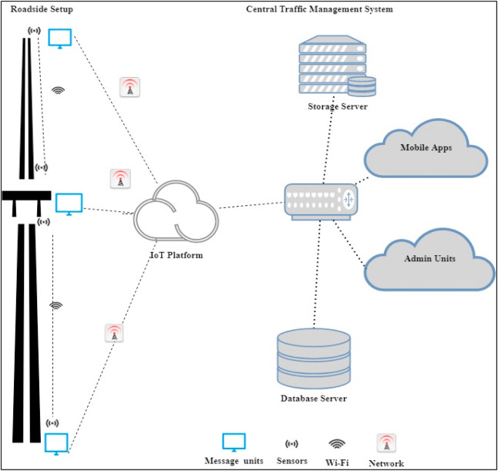

**System** **architecture:**

An IoT based system architecture mostly contains a sensing layer, network layer, service layer, and an application layer [[54](https://www.sciencedirect.com/science/article/pii/S2589791820300207#bib54)]. The sensing layer acquires data from the things, the network layer transfers the collected data from devices to the service layer, the service layer controls the devices and analyzes the collected data, and finally, the application layer which indicates the user interface. The layered architecture is presented in [Fig. 4](https://www.sciencedirect.com/science/article/pii/S2589791820300207#fig4).

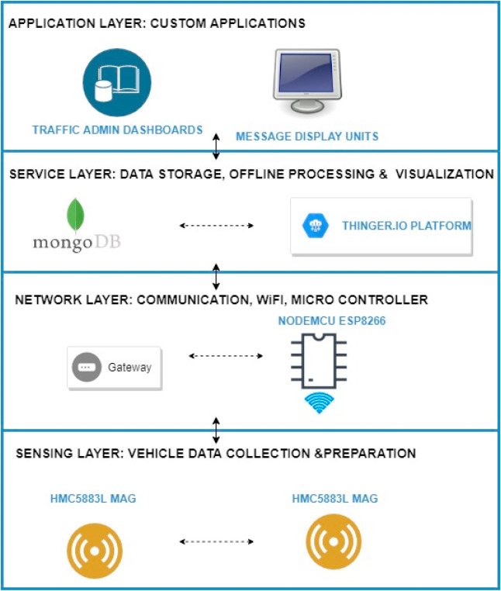

1. [Download : Download full-size image](https://ars.els-cdn.com/content/image/1-s2.0-S2589791820300207-gr4.jpg)

Fig. 4. System architecture.

The four main system development activities are: (i) populate geographical map details for a given location, (ii) detect vehicle and estimate vehicle length, (iii) determine growing queue, and (iv) display traffic updates. The system components include (i) Geographical map, (ii) Sensors, (iii) Microcontroller, (iv) IoT platform, (v) Database, and (vi) Electronic display units. The activities, the software, and hardware components associated with each activity are given in [Fig. 5](https://www.sciencedirect.com/science/article/pii/S2589791820300207#fig5).

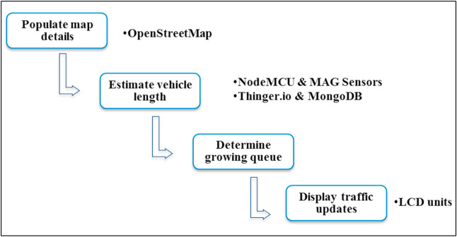

**Hardware and software components:**

An extensive literature review has been conducted to select various system components and [technologies](https://www.sciencedirect.com/topics/earth-and-planetary-sciences/science-and-technology) .The hardware and software components used for the system development are given below.

**OpenStreetMap**:

The OpenStreetMap (OSM) is one of the practical projects that provide map data . The map data provided by OSM is free to use . The individual users are contributed to the development of OSM, and the geographical information contributed by them is the core part of OSM. OSM provides editing, exporting, and uploading functionalities. The export functionality can be used to generate row map data or map images. The raw data can be processed by other systems that use geographical information. The OSM also provides a java interface to edit and work with maps, i.e., Java OpenStreetMap (JOSM) editor, similar to traditional geographic information system packages.

**MongoDB:** MongoDB is a document database, and it stores the data from JSON like documents. MongoDB provides flexible access to data and supports nested objects as values. MongoDB has both community and enterprise versions . The community version of MongoDB is used in this research. A record in MongoDB consists of field and value pairs and basically, it is a document. The documents in MongoDB are stored as collections, and similar to tables. The OpenStreetMap downloaded and converted to geojson format and stored in the MongoDB for experiments. We selected MongoDB due to its performance and rich [query language](https://www.sciencedirect.com/topics/earth-and-planetary-sciences/query-language).

**Magnetic Sensors**:

The magnetic sensor has the following advantages

(i) it can be easily installed on roadsides,

(ii) reduces detection error,

(iii) there is no climate influence

Honeywell HMC5883L is a tri-axial magnetic sensor used in many traffic monitoring research due to its high sensitivity . and cost-effectiveness. Hence, this research also used the HMC5883L magnetic sensor to collect vehicle data. It is worth to note that there exist many PCBs with all the necessary components for vehicle detection and classification as discussed in related work, section  These boards have individual physical sensors as well as the firmware. It is also a good idea to go ahead with these readymade nodes as they are cost-effective and the expected cost of a single node is less than $50.

**NodeMCU:**

 NodeMCU is a firmware developed for ESP8266 WiFi [system on chip](https://www.sciencedirect.com/topics/engineering/system-on-chip) (SoC). It is also an open-source platform. NodeMCU helps to prototype IoT products . ESP8266 has a general-purpose input/output interface , hence the sensors/devices can be integrated easily. NodeMCU board has WiFi capability, digital pins (D0-D8), analog pin (A0), and supports [serial communication](https://www.sciencedirect.com/topics/engineering/serial-communication) protocols (I2C, UART, etc.). ESP8266 chip is developed by Espressif System ESP8266 has 2.4 GHz WiFi, 64 KB boot ROM, 96 KB data [RAM](https://www.sciencedirect.com/topics/engineering/reliability-availability-and-maintainability-reliability-engineering), and 64 KB instruction RAM. ESP8266 module can be used for end to end IoT system developments.

**Thinger. io:**

 Thinger. io is an open-source IoT platform that supports [sensor data collection](https://www.sciencedirect.com/topics/engineering/sensor-data-collection), management, analysis, and visualization . Thinger. io supports the deployment of [data fusion](https://www.sciencedirect.com/topics/earth-and-planetary-sciences/multisensor-fusion) applications with the integration of cloud, IoT technologies, and big data. It supports the remote sensing and [actuation](https://www.sciencedirect.com/topics/engineering/actuation) of any sensor, and provide readymade services to connect devices. Thinger. io is unique in terms of transmission efficiency by providing an optimized encoding scheme, namely Protoson Thinger. io is highly interoperable and provides real-time bidirectional communications. The storage management mechanism of Thinger. io is called data buckets and supports document storages such as MongoDB. The Thinger. io platform offers an interface to configure devices, create data buckets, and model devices in this research.

**LCD Unit:** The message board unit can be a WiFi-enabled character type LCD unit. However, to experiment, a 16 x 02 LCD unit was used that can display only 32 characters.

## Limitations and future work:

There are some limitations on the proposed model, which need to be enhanced further. The proposed system uses WiFi to communicate between devices; however, their energy consumptions and solutions to recharge them are not considered in this study. Alternate solutions such as solar charging or charging from street lights can be further looked at. Similarly, the proposed model is tested only in the context of the single-lane road as intended. However, it would be useful to test the system in a multi-lane scenario to identify the false detections.

For future directions, the proposed system could be further improved considering different aspects. The first dimension is suggesting an optimal route for the drivers based on real-time data.

The dynamic traffic signal control functionality is also considered as future work. In this case, the communication of roadside display units and traffic signals have to be established. Another aspect is the real-time implementation of the system including the IoT security features in the communication layer; the prototype has to be extended to a complete end-to-end system with central server communication. Moreover, the integration of IoT security, communication between display units, and traffic signals will be investigated in future research.

## Conclusion:

This research proposed an IoT based system model to collect, process, and store real-time traffic data. This research provided real-time traffic monitoring for traffic updates through roadside message units. The traffic authorities can also broadcast messages on [VIP](https://www.sciencedirect.com/topics/medicine-and-dentistry/vasoactive-intestinal-polypeptide) visits, medical emergencies, accidents, etc. to corresponding message units, which will assist the public in decision making and save their time on roads can be avoided.

Python code:

import tkinter as tk  
import requests  
  
def get_route_info():  
 current_location = current_location_entry.get()  
 destination = destination_entry.get()  
   
 # send a request to the bus route API to retrieve the route and arrival time  
 route_info = requests.get(f"https://api.busroute.com?origin={current_location}&destination={destination}")  
   
 # extract the route and arrival time from the response  
 route = route_info["route"]  
 arrival_time = route_info["arrival_time"]  
   
 # display the route and arrival time in the results label  
 results_label["text"] = f"Route: {route}\nEstimated Arrival Time: {arrival_time}"  
   
# create the main window  
window = tk.Tk()  
window.title("Bus Route App")  
  
# create the input fields and buttons  
current_location_label = tk.Label(text="Current Location:")  
current_location_entry = tk.Entry()  
destination_label = tk.Label(text="Destination:")  
destination_entry = tk.Entry()  
get_route_button = tk.Button(text="Get Route", command=get_route_info)  
  
# create the results label  
results_label = tk.Label(text="")  
  
# add the elements to the window  
current_location_label.pack()  
current_location_entry.pack()  
destination_label.pack()  
destination_entry.pack()  
get_route_button.pack()  
results_label.pack()  
# run the main loop

window.maimloop()